


E

Operate a cellar system
D1.HBS.CL5.05
Trainee Manual






Operate a cellar system

D1.HBS.CL5.05

Trainee Manual





Project Base
William Angliss Institute of TAFE
555 La Trobe Street
Melbourne 3000 Victoria
Telephone: | (03) 9606 2111
Facsimile: | (03) 9670 1330
Acknowledgements
Project Director: | Wayne Crosbie
Chief Writer: | Alan Hickman
Subject Writer: | Nick Hyland
Project Manager: | Alan Maguire
Editor: | Jim Irwin
DTP/Production: | Daniel Chee, Mai Vu, Riny Yasin, Kaly Quach

The Association of Southeast Asian Nations (ASEAN) was established on 8 August 1967. The Member States of the Association are Brunei Darussalam, Cambodia, Indonesia, Lao PDR, Malaysia, Myanmar, Philippines, Singapore, Thailand and Viet Nam.
The ASEAN Secretariat is based in Jakarta, Indonesia.
General Information on ASEAN appears online at the ASEAN Website: www.asean.org.
All text is produced by William Angliss Institute of TAFE for the ASEAN Project on “Toolbox Development for Front Office, Food and Beverage Services and Food Production Divisions”.
This publication is supported by the Australian Government’s aid program through the ASEAN-Australia Development Cooperation Program Phase II (AADCP II).
Copyright: Association of Southeast Asian Nations (ASEAN) 2013.
All rights reserved.
Disclaimer
Every effort has been made to ensure that this publication is free from errors or omissions. However, you should conduct your own enquiries and seek professional advice before relying on any fact, statement or matter contained in this book. The ASEAN Secretariat and William Angliss Institute of TAFE are not responsible for any injury, loss or damage as a result of material included or omitted from this course. Information in this module is current at the time of publication. Time of publication is indicated in the date stamp at the bottom of each page.
Some images appearing in this resource have been purchased from stock photography suppliers Shutterstock and iStockphoto and other third party copyright owners and as such are non-transferable and non-exclusive. Clip arts, font images and illustrations used are from the Microsoft Office Clip Art and Media Library. Some images have been provided by and are the property of William Angliss Institute.
Additional images have been sourced from Flickr and SXC and are used under Creative Commons licence: http://creativecommons.org/licenses/by/2.0/deed.en

File name: TM_Operate a cellar system_refined





Table of contents
Introduction to trainee manual 1
Unit descriptor 3
Assessment matrix 5
Glossary 7
Element 1: Operate and maintain bulk dispensing systems 9
Element 2: Operate and maintain beer reticulation systems 25
Element 3: Use and maintain refrigeration systems 39
Element 4: Monitor quality of cellar products 51
Presentation of written work 63
Recommended reading 65
Trainee evaluation sheet 67
Trainee self-assessment checklist 69

Introduction to trainee manual

To the Trainee
Congratulations on joining this course. This Trainee Manual is one part of a ‘toolbox’ which is a resource provided to trainees, trainers and assessors to help you become competent in various areas of your work.
The ‘toolbox’ consists of three elements:
- A Trainee Manual for you to read and study at home or in class
- A Trainer Guide with Power Point slides to help your Trainer explain the content of the training material and provide class activities to help with practice
- An Assessment Manual which provides your Assessor with oral and written questions and other assessment tasks to establish whether or not you have achieved competency.
The first thing you may notice is that this training program and the information you find in the Trainee Manual seems different to the textbooks you have used previously. This is because the method of instruction and examination is different. The method used is called Competency based training (CBT) and Competency based assessment (CBA). CBT and CBA is the training and assessment system chosen by ASEAN (Association of South-East Asian Nations) to train people to work in the tourism and hospitality industry throughout all the ASEAN member states.
What is the CBT and CBA system and why has it been adopted by ASEAN?
CBT is a way of training that concentrates on what a worker can do or is required to do at work. The aim is of the training is to enable trainees to perform tasks and duties at a standard expected by employers. CBT seeks to develop the skills, knowledge and attitudes (or recognise the ones the trainee already possesses) to achieve the required competency standard. ASEAN has adopted the CBT/CBA training system as it is able to produce the type of worker that industry is looking for and this therefore increases trainees’ chances of obtaining employment.
CBA involves collecting evidence and making a judgement of the extent to which a worker can perform his/her duties at the required competency standard. Where a trainee can already demonstrate a degree of competency, either due to prior training or work experience, a process of ‘Recognition of Prior Learning’ (RPL) is available to trainees to recognise this. Please speak to your trainer about RPL if you think this applies to you.
What is a competency standard?
Competency standards are descriptions of the skills and knowledge required to perform a task or activity at the level of a required standard.
242 competency standards for the tourism and hospitality industries throughout the ASEAN region have been developed to cover all the knowledge, skills and attitudes required to work in the following occupational areas:
- Housekeeping
- Food Production
- Food and Beverage Service
- Front Office
- Travel Agencies
- Tour Operations.
All of these competency standards are available for you to look at. In fact you will find a summary of each one at the beginning of each Trainee Manual under the heading ‘Unit Descriptor’. The unit descriptor describes the content of the unit you will be studying in the Trainee Manual and provides a table of contents which are divided up into ‘Elements’ and ‘Performance Criteria”. An element is a description of one aspect of what has to be achieved in the workplace. The ‘Performance Criteria’ below each element details the level of performance that needs to be demonstrated to be declared competent.
There are other components of the competency standard:
- Unit Title: statement about what is to be done in the workplace
- Unit Number: unique number identifying the particular competency
- Nominal hours: number of classroom or practical hours usually needed to complete the competency. We call them ‘nominal’ hours because they can vary e.g. sometimes it will take an individual less time to complete a unit of competency because he/she has prior knowledge or work experience in that area.
The final heading you will see before you start reading the Trainee Manual is the ‘Assessment Matrix’. Competency based assessment requires trainees to be assessed in at least 2 – 3 different ways, one of which must be practical. This section outlines three ways assessment can be carried out and includes work projects, written questions and oral questions. The matrix is designed to show you which performance criteria will be assessed and how they will be assessed. Your trainer and/or assessor may also use other assessment methods including ‘Observation Checklist’ and ‘Third Party Statement’. An observation checklist is a way of recording how you perform at work and a third party statement is a statement by a supervisor or employer about the degree of competence they believe you have achieved. This can be based on observing your workplace performance, inspecting your work or gaining feedback from fellow workers.
Your trainer and/or assessor may use other methods to assess you such as:
- Journals
- Oral presentations
- Role plays
- Log books
- Group projects
- Practical demonstrations.
Remember your trainer is there to help you succeed and become competent. Please feel free to ask him or her for more explanation of what you have just read and of what is expected from you and best wishes for your future studies and future career in tourism and hospitality.

Unit descriptor
Operate a cellar system
This unit deals with the skills and knowledge required to Operate a cellar system in a range of settings within the hotel and travel industries workplace context.
Unit Code:
D1.HBS.CL5.05
Nominal Hours:
45

Element 1: Operate and maintain bulk dispensing systems
Performance Criteria
1.1 Operate bulk dispensing systems in accordance with manufacturer's instructions and safety requirements
1.2 Monitor temperature, carbonation and pump pressure
1.3 Clean connectors, extractors and heads hygienically
1.4 Set up nitrogen and integrated systems safely in accordance with manufacturer's specifications
1.5 Identify faulty products and product delivery problems promptly and implement corrective action

Element 2: Operate and maintain beer reticulation systems
Performance Criteria
2.1 Operate and clean beer reticulation systems in accordance with manufacturer’s instructions
2.2 Follow safety procedures regarding handling, connecting and storing of gas

Element 3: Use and maintain refrigeration systems
Performance Criteria
3.1 Measure refrigerator temperatures accurately and adjust correctly to comply with product requirements
3.2 Clean and maintain refrigerator components
3.3 Set or re-set walk-in alarms to manufacturer's specifications
3.4 Recognise and repair/report basic mechanical faults in accordance with enterprise procedures

Element 4: Monitor quality of cellar products
4.1 Test regularly quality of cellar products and identify faults
4.2 Make adjustments within scope of individual responsibility or report faults to the appropriate person or people
4.3 Use bin and keg card systems to assist in monitoring the quality of products and controlling stock
4.4 Keep cellar tidy, clean and free from litter
4.5 Monitor cellar temperature

Assessment matrix
Showing mapping of Performance Criteria against Work Projects, Written Questions and Oral Questions
The Assessment Matrix indicates three of the most common assessment activities your Assessor may use to assess your understanding of the content of this manual and your performance - Work Projects, Written Questions and Oral Questions. It also indicates where you can find the subject content related to these assessment activities in the Trainee Manual (i.e. under which element or performance criteria). As explained in the Introduction, however, the assessors are free to choose which assessment activities are most suitable to best capture evidence of competency as they deem appropriate for individual students.
 |  |  | Work Projects | Written Questions | Oral Questions
Element 1: Operate and maintain bulk dispensing systems
1.1 | Operate bulk dispensing systems in accordance with manufacturer's instructions and safety requirements |  | 1.1 | 1,2 | 1
1.2 | Monitor temperature, carbonation and pump pressure |  | 1.2 | 3,4 | 2
1.3 | Clean connectors, extractors and heads hygienically |  | 1.3 | 5,6 | 3
1.4 | Set up nitrogen and integrated systems safely in accordance with manufacturer's specifications |  | 1.4 | 7,8 | 4
1.5 | Identify faulty products and product delivery problems promptly and implement corrective action |  | 1.5 | 9,10 | 5
Element 2: Operate and maintain beer reticulation systems
2.1 |  | Operate and clean beer reticulation systems in accordance with manufacturer’s instructions | 2.1 | 11,12 | 6
2.2 |  | Follow safety procedures regarding handling, connecting and storing of gas | 2.2 | 13,14 | 7
Element 3: Use and maintain refrigeration systems
3.1 | Measure refrigerator temperatures accurately and adjust correctly to comply with product requirements |  | 3.1 | 15,16 | 8
3.2 | Clean and maintain refrigerator components |  | 3.2 | 17,18 | 9
3.3 | Set or re-set walk-in alarms to manufacturer's specifications |  | 3.3 | 19 | 10
3.4 | Recognise and repair/report basic mechanical faults in accordance with enterprise procedures |  | 3.4 | 20 | 11
Element 4: Monitor quality of cellar products
4.1 | Test regularly quality of cellar products and identify faults |  | 4.1 | 21,22 | 12
4.2 | Make adjustments within scope of individual responsibility or report faults to the appropriate person or people |  | 4.2 | 23,24 | 13
4.3 | Use bin and keg card systems to assist in monitoring the quality of products and controlling stock |  | 4.3 | 25,26 | 14
4.4 | Keep cellar tidy, clean and free from litter |  | 4.4 | 27,28 | 15
4.5 | Monitor cellar temperature |  | 4.5 | 29,30 | 16

Glossary
Term | Explanation
Beer line | Between coupler and faucet, beer travels through beer line selected to fit the needs of the specific draft application
Beer tap | On/off tap to dispense beer into a glass
Cellar | The main area designed to store alcohol that is to be served in a bar operation
CO₂ | Carbon Dioxide
°C | Degree Celsius
Dispense | To pour beverage
Faucet | Tap used to dispense beer to the glass
Gas Source | Gas used to supply pressure to push beer from the keg to the faucet
Keg | A cask or barrel, usually holding from 20 to 50 litres
Regulator | A regulator adjusts and controls the flow of gas from any source
Sanitise | Use of heat and or chemical to kill bacteria, fungi and viruses
Soda | Carbonated non-alcoholic beverage
Syrup | A concentrated beverage flavouring agent
Tail Pieces and Connectors | Tail pieces connect couplers, wall bracket, shanks or any other piece of equipment to vinyl tubing or other types of beer line
Thermostat | Tool which measures temperature to open or close a valve

Element 1:
Operate and maintain bulk dispensing systems

1.1 Operate bulk dispensing systems in accordance with manufacturer's instructions and safety requirements

Introduction
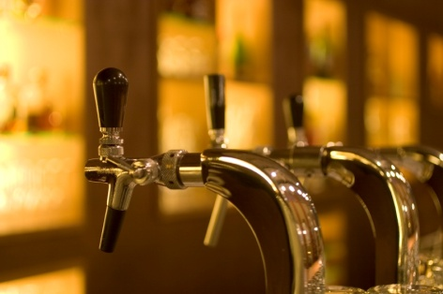
All beverage establishments will serve a range of beverage items to customers. Whilst the names and brands of beverage items may differ to suit the needs of the establishment, the most common types of beverages will be served in all establishments.
Many bars, especially those who operate high volume sales will have cellar operations to help facilitate their operations.
Most food and beverage establishments deal with large volumes of trade each and every day.
It is essential that any bar operation is able to prepare and serve beverages:
- In a desired state
- Consistently
- In a timely manner
- To maximise profits.
This section will focus on what equipment is commonly found in a cellar operation and the role of the cellar operator in ensuring this area is run efficiently.

Cellar area
This is the main area designed to store all alcohol and associated products that are to be served in a bar operation.
This includes, but is not limited to:
- Wine casks, bottles and bulk boxes
- Beer kegs, bottles, cans and cartons
- Spirit bottles and bulk containers
- Soft drink bottles, cans and bulk boxes
- Juices, milk, cream
- Snacks.

Bulk dispensing systems
One of the main components of a cellar operation is the use of bulk dispensing systems.
In order to be able to serve large volumes of beverages in an appropriate time, most establishments will use bulk dispensing systems.
Benefits of bulk dispensing systems
- Provides accurate and consistent drink portion sizes
- Improves speed of beverage dispensing
- Increases volume of sales
- Improves efficiency for staff
- Reduces waiting time for customers
- Provides a clear record of drinks poured by station, shift and staff member.
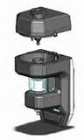
Types of bulk dispensing systems
These may include:
- Beer
- Spirits
- Wine
- Post-mix
Beer system
Keg beer is the most common bulk beer dispensing system. Keg beer is a term for beer which is served from a pressurised keg.
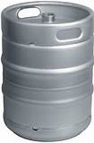
Kegs are commonly used in many establishments as they store large quantities of beer, which not only makes the sale of beer cost effective but the transporting of beer easier, as large kegs are moved as opposed to.
A keg has a single opening in the centre of the top to which a flow pipe is attached. Kegs are artificially pressurised after fermentation with carbon dioxide or a mixture of carbon dioxide and nitrogen gas.
The finer workings of beer systems will be described in more detail in Section 2.1 of this manual.

Spirits system
Electronic dispensing units (EDU) are becoming popular as it not only makes the pouring of spirits more consistent and accurate, but an easier process.
Bottle dispensing units
These units draw spirit units directly from bottles.
This allows a specific measure of spirit, normally in 30ml volumes, to be served.
The only handling of bottles will take place when bottles are empty.
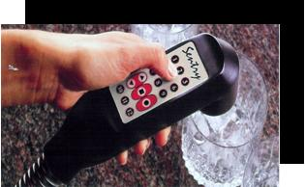
In most cases an accurate record of the number of dispensed shots are recorded which helps the reconciliation process and identifies when discrepancies exist.
Bulk dispensing units
These are common in high volume establishments allowing a number of spirits to be fed from a central store, drawing directly from 20 litre plastic bulk liquor containers.
Spirit guns
Enables pre-mixed spirits to be served in a simple to use ‘gun’. This gun operates in a similar fashion to a soda post mix system. This will be explained later in the section.
Benefits of dispensing units
There are many benefits of using electronic spirit dispensing systems including:
- Simple bottle loading and replacement
- Reduced wastage of spirits
- Easy assembly of minimal parts for quick washing and maintenance
- Factory-set displacement valve and clear viewing bowl ensure accurate measures every time
- Dispensing indicator lights guarantee a fool-proof system
- Digital counters record every shot dispensed for accurate assessment checks
- Low impact, single-touch button makes pouring simple
- Reliable power supply unit with lockable keys for maximum security.
Wine system
Bulk wine dispensing systems have become a great revenue earner for many beverage establishments.
As the demand for wine continues to grow, so does the need to satisfy customers with innovative and environmentally friendly wine service.
As previously discussed, there are many benefits of using bulk dispensing units, and this also applies with the service of high volume wine.
Serving glasses or carafes of your wine from a dispense tap is highly efficient.

Benefits of using a bulk wine dispensing unit include:
- It replaces the need to order, open and stock wine bottles
- It reduces the cost of packaging when purchasing wines in bulk
- Spoilage is practically non-existent
- It reduces loss of quality from opened bottles
- It is an effective technique to increase sales by offering small sample pours.
Post-mix system
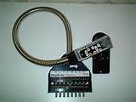
A post mix system is the collective of equipment used to serve high volumes of carbonated beverages.
A soda or bar gun is a device used by bars to serve various types of carbonated and non-carbonated drinks. A soda gun has the ability to serve any beverage that is some combination of syrup, water and carbon dioxide. This includes soft drinks, iced tea, carbonated water, and plain water.
Soda guns have buttons corresponding to the drink to be served. Each button is generally labelled with one letter; the meanings of these letters are almost universal.
Button | Meaning
Q | Tonic Water
L | Lemon-lime (7-Up, Sprite, Sierra Mist)
G | Ginger Ale
C | Coca-Cola
D | Diet Coke
S | Club Soda
W | Water
O | Orange Soda
P | Pineapple juice
C | Cranberry soda
SS | Sour Mix

Comparison with bottled drinks
The advantages of dispensing from a bar gun instead of bottles include:
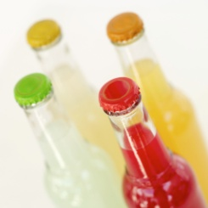
- Lower cost of transport - because water is added at the point of sale
- Convenience - no need to locate and open bottles or cans; a single canister contains much more product than a bottle
- A freshly carbonated drink for the consumer
- Much more profitable product for the venue - a glass of post mix costs far less than the same amount of comparable drink from a bottle.
Post-mix systems result in significantly decreases green house gas emissions due to reduced weight in the supply of the concentrated bag-in-box syrup versus supply and recycling of bottled beverages.
If the system is not properly maintained, it will serve an inferior drink. If the bar owner chooses, he or she can set the ratio of syrup to water to a lower than optimal rate, thus saving the restaurant money in syrup costs but resulting in an inferior drink.
Post mix soda gun
A post mix soda gun combines concentrated syrup from a bag-in-box and mixes it with filtered tap water, either carbonated or non-carbonated at the point of dispense. For a post mix soda gun to function it must be connected to a bag-in-box system, including pumps, a chiller, water filtration system and a carbonator.
Due to the complexity and expense of purchasing and configuring the entire system that runs the soda gun, in most cases the restaurant relies on their beverage supplier to supply the equipment and handle the installation and maintenance. A post-mix soda gun is able to supply any beverage product that can be dispensed in bag-in-box form that does not have pulp.
Pre mix soda gun
Premix soda guns are connected to a simpler system that closely resembles a draft beer system. The drink is supplied to a restaurant in pressurised canisters that are connected to the premix soda gun. Premix soda guns are primarily used in countries where the supply of water cannot easily be filtered to a level suitable for use in a restaurant.
Other components of a cellar
The different components that make up a fully operational cellar, besides the above mentioned bulk dispensing units include, but are not limited to:
- Cool room
- Transfer leads
- Couplers
- Connectors
- Gas regulators
- Chemicals, cleaning equipment and procedures
- Safety goggles and gloves
- Approved cleaning keg or dosing unit
- Appropriate stock.
Role of cellar attendant
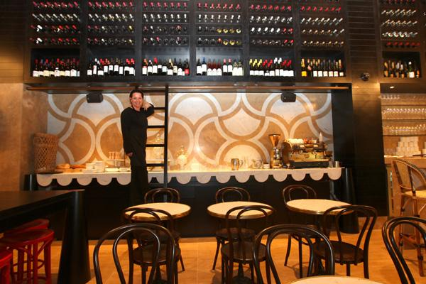
To date we have looked at some of the key pieces of equipment located in a cellar. Now it is time to look at the role of the person responsible for this area. The role of the cellar attendant may be filled by one person or the activities associated with this role shared amongst bar staff.
The cellar attendant plays an important role in ensuring adequate supplies of beverages to bars and controlling stock to avoid waste or theft. A good cellar attendant will therefore contribute directly to the profitability and smooth running of an establishment.
Bulk Beverage system
- Cleaning and maintaining the draft beer system and keeping records up to date of equipment servicing
- Monitoring the quality, temperature and service of beer in bars
- Ability to find and correct faults in the draft beer system
- Monitoring bulk post mix, wine and spirit systems
- Observing current Standards for occupational safety and health including the safe use of gas and chemicals and the hygienic handling of alcohol.
Stock control
- Knowledge of all liquor groups and correct storage procedures for stock
- Ordering stock from suppliers
- Supplying stock to bars
- Receiving, checking and storing deliveries, checking invoices and delivery notes and dealing with any discrepancies
- Maintaining the cellar records of all stock coming in and going out
- Conducting regular stock takes
- Keeping all cellar and storage areas locked and controlling access to the keys
- Rotating and storing stock correctly to avoid deterioration or spoilage.
Safety guidelines for the Cellar Attendant:
- Wear safety boots
- Wear Personal Protective Equipment when handling chemicals
- Beware of CO₂ gas leaks
- Beware of light fittings in wet conditions
- Do not lift full kegs, use a trolley, or for short distances, roll keg along on bottom rim. Lift using your legs not your back
- Keep the cellar clean, neat and tidy at all times
- Keep cellar equipment in good repair and take faulty equipment out of service
- Report unsafe equipment or conditions to management
- Employ a service technician to repair equipment you are uncertain of handling and especially high risk equipment such as gas valves, refrigeration equipment and anything electrical.

1.2 Monitor temperature, carbonation and pump pressure

1.3 Clean connectors, extractors and heads hygienically

1.4 Set up nitrogen and integrated systems safely in accordance with manufacturer's specifications

1.5 Identify faulty products and product delivery problems promptly and implement corrective action
Introduction
For the purposes of this manual, these sections have been grouped together. Given that most bulk alcohol dispensing units have their own parts, designs and characteristics it is important to describe how to operate and maintain each system, as opposed to explaining key activities that may not relate or require different maintenance tasks, depending on the system itself.
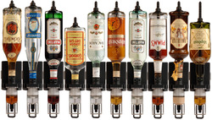
It is important to note that for each of the above mentioned bulk dispensing systems, different manufacturers will have different requirements. The manual tries to provide generic information that for the most part provides an understanding of how the systems work in general.
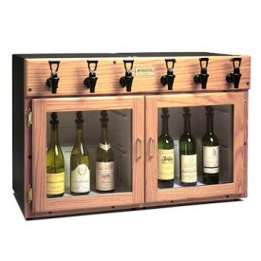
In this section we will explore how to operate and maintain:
- Spirit dispensing systems
- Wine dispensing systems
- Post mix dispensing systems.
In section 2 of this manual we will explore how to operate and maintain beer dispensing systems.

Spirit dispensing systems
Using spirit bottle dispensing units
Whilst different spirit dispensing systems require different instructions, most bottle dispensing units have similar usage procedures. These simple procedures are explained below.
1 After installing the Spirit Dispenser, release the dispenser from its support pushing downwards from the aluminium pine located below the hook. | 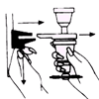
2 Invert the dispenser with the rubber cone and introduce it into the bottle bracket while pressing firmly. | 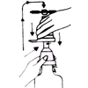
3 While firmly holding the bottle with one hand and the dispenser with the other, place the bottle vertically with the tip downwards, introduce it into the support and wait until the drink deposit is full. | 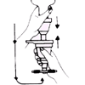
4 Place the edge of the glass below the star and press upwards firmly until the deposit is empty. Clear the glass quickly. Remember that you must never interrupt the filling process. | 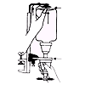
5 Once a week, it is recommended to clean the dispensing mechanism used for syrupy liqueurs, or spirits with a high content of sugar. | 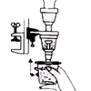

Wine dispensing systems
Wine preservation and dispensing systems are becoming popular in many beverage establishments. These systems are normally designed to fit and preserve one to 8 bottles depending on the specific equipment being used.
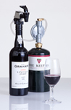
Benefits of wine dispensing systems
- Helps aid fast dispensing of wine in high volume environments
- These systems will preserve wine with nitrogen gas to prevent off flavours or colours caused by oxidation
- Ensure quality of wine remains
- Reduces wastage
- Increase the value of every bottle of wine dispensed.
Steps to using wine dispensers
Again different models will have different instructions; however the general technique is similar.
Wine dispensers use compressed gas cylinders, with each disposable cylinder having the ability to preserve and dispense up to 25 bottles of wine.
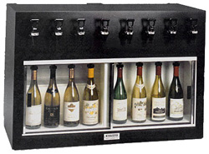
- Uncork or open the wine and insert the dispenser’s stopper faucet
- Plug in the gas source
- Dispense your wine into glasses for serving
- After using the wine dispenser, unplug the tubing and store the unfinished bottles
- Wine that is served with a wine dispenser should be stored in the same way you would store that wine were you not using the dispenser.
Post mix dispensing systems
A post-mix system is like a miniature soft drink factory. A carbonator carbonates the water from the building water supply. It is then refrigerated along with syrup that is pumped from large containers containing popular beverages that are served by themselves or combined with common spirits. These two ingredients are then precisely mixed within the dispensing valve and poured into the cup. A finished drink manufactured on-site.
Main components of a post mix dispensing system
The main components include:
- Water – main ingredient of all beverages
- CO₂ – this is used to CO₂ is used to carbonate the water and to propel the syrup. CO₂ is dissolved into water by lowering the temperature of the water or increasing the pressure of the CO₂ gas using a carbonator. Booster pumps force the water to increase in pressure, allowing the CO₂ to dissolve into the water.
- Carbonator
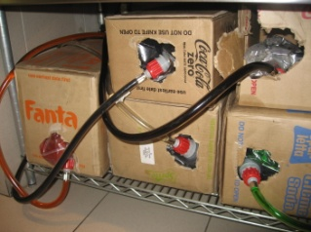
- Syrup – contains the ‘flavour’ of the beverage. Soda water is mixed with flavoured syrup in order to create the soft drink. The syrup and carbonated water mix together and exit out of the nozzle, which is activated a lever is pulled down or a button pushed. The syrup is often stored in plastic bags that are hooked up to tubes. The soda flavouring is drawn from the plastic bags using air pressure.
Dispenser – pours finished product into selected container or glass.
Types of systems
There are three main systems. These include:
Countertop electric refrigeration
The countertop dispenser is a mechanically refrigerated water bath style cooling unit with valves mounted on the front of the dispenser.
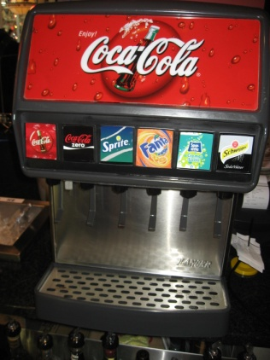
Ice cooled system
With an ice-cooled system the refrigeration type is the main difference. Here the refrigeration consists of a bin which holds ice and has a cold plate in the bottom, through which the syrup and water is cooled for your post-mix drink.
Remote Refrigeration Cooling
A remote system separates the dispensing valves from the refrigeration system. Carbonated water or water bath water is circulated between the refrigeration unit and the dispensing valves to insure that a cold product will be dispensed.
Regardless of the system being used, the ability to serve top quality drinks, insuring customer satisfaction and guaranteeing optimum profits are all dependent on properly functioning equipment.
Handling CO₂ (Carbon Dioxide)
The CO₂ can run out and you need to know how to replenish it.
Not only is it important to replace CO₂ correctly to ensure the quality of beverages, but it is essential to prevent CO₂ gas leaks in the entire CO₂ and soft drink system.
If a CO₂ gas leak is suspected, particularly in a small area, immediately ventilate the contaminated area before attempting to repair the leak.
Personnel exposed to high concentration of CO₂ gas will experience tremors which are followed rapidly by loss of consciousness and suffocation.
Most CO₂ cylinder regulator has a PSI gauge that indicates the internal pressure in the cylinder. This gauge shows when the cylinder is about to go empty.
A gauge will indicate when all the liquid CO₂ has been used and only gas remains.
This is the best time to replace the cylinder before it runs out. The cylinder valve must be open or the gauge will not register.
When changing an empty cylinder it is important to record the operating pressure so the pressure can be reset later.

Changing the CO₂ Cylinder
Fully close the cylinder valve and adjust the regulator to zero pressure by turning the screw counter clockwise.
This protects the regulator against damage when installing it on a full cylinder.
Using a wrench, loosen the coupling nut and remove the regulator from the cylinder. It is normal for a small amount of CO₂ gas to escape when removing the regulator.
Remove the chain or whatever is securing the cylinder and remove the empty cylinder. Move a full cylinder in place and secure it. Attach the regulator to the cylinder and tighten the coupling nut and open the valve.
The regulator should now be adjusted to the operating pressure recorded earlier. Your CO₂ system is now in back in operation.
Always keep the cylinder valve closed when the cylinder is not in use. Even if the cylinder is empty, always store the cylinder in a well ventilated area. CO₂ can accumulate in closed areas and this can be dangerous.
Handling box syrup
Post-Mix syrup containers are usually cardboard outer boxes containing a strong plastic inner bag of syrup. When a container becomes empty it is simple to remove it and replace it with a full container.
The syrup pump is connected to the syrup container with a Quick-Disconnect.
The Quick-Disconnect can be removed from the bag by withdrawing the plunger and then lifting the Quick-Disconnect from the bag fitting.
Remove the empty syrup box.
On a new syrup container pull out the bag fitting and lock it in place with the box tab.
Before connecting the quick-disconnect to a new syrup container, rinse the quick–disconnect in warm water to remove any syrup residue that may have accumulated. This will keep the Quick-Disconnect operating freely.
Attach the quick disconnect to the bag fitting and engage it by pressing the probe into the fitting.
Spilled syrup will attract insects and promote bacteria growth, so clean up any spilled syrup immediately.
It is important to keep the area clean.

General cleaning activities

Daily Cleaning
- Take off the cup rest from the machine to wash in warm soapy water, then reinstall
- Wash the exterior down, again using warm soapy water, rinse it and dry thoroughly
- Remove the valve nozzles from the machine and wash it in warm, soapy water. Reinstall.

Weekly Cleaning
- Wash the diffusers in warm water
- Clean the ice chute
- Wash the nozzles with warm water.

Monthly Cleaning
- Remove the splash plate and clean it in warm soapy water
- Clean the panel behind the splash plate with warm, soapy water. Replace the splash plate
- Flush the syrup lines:
- Sanitise a bucket
- Fill the bucket with water and a sanitising solution as recommended by your manufacturer
- Wear clean plastic gloves
- Remove the syrup line from all bags in boxes
- Open the valve and soak it in your bucket
- Use a plastic bag or glove to cover the connectors
- Empty, rinse, and fill the bucket with hot water, not above 80°C
- Take plastic from the connector and place in the hot water
- Activate the valve at the soda machine
- Flush the line until the bucket is empty and repeat two or three times
- Take the connector from the bucket and attach it to the new bag in box
- Activate the valve at the soda machine until all the water flushes through.
Cleaning soda dispensing lines
Soda dispensers can develop a funny or off taste for a few reasons. The two most common causes are changing soda flavours or mould and mildew growing in the lines. Both of these circumstances can happen with a flavour that isn't very popular and thus not used very much.
Syrup can stay in the line instead of being flushed through by regular use. The syrup can dry and leave residue on the inside of the lines, or air pockets can form which can hold mould spores. Both of these problems can be remedied by flushing and cleaning the lines in your soda machine.
- Remove the take-up end of the line from the syrup bag. Place the take-up line end into a bucket with 2 gallons of hot water. Push the soda dispenser lever as if you were filling a cup. The machine will begin to suck the hot water into the lines. Run the full bucket of water through the lines
- Mix together 2 gallons of hot water and 1 cup of baking soda. Stir thoroughly to make sure that all of the baking soda has dissolved. Run the entire contents of this bucket through your soda lines
- Make 2 gallons of sanitising solution. Most restaurants will have their own brand of commercial sanitiser. Mix yours according to the package directions. If you have no sanitiser on hand, make a sanitising bleach solution by mixing 2 tbs. of household bleach with 2 gallons of warm water. Mix all solutions carefully, paying attention to water temperature requirements as well as ingredient amounts. Most sanitisers require room temperature water instead of hot water. Run this solution through your soda lines
- Place the take-up end of the soda line into another bucket of hot water. Run 3 gallons of clear water through your lines to completely rinse them of residue. Reconnect the take-up end of the line to the syrup bag. Discard the first half gallon of dispensed soda.
Sanitising soda machines
Keeping the nozzles properly cleaned and the soda machine properly sanitised is important to avoid health risks, but the costs and effort are minimal. Only the nozzles need to be sanitised as the actual soda lines are not exposed to air or bacteria
- Mix the sanitiser with cold water in a sink or bucket. Sanitising solution is available at restaurant supply stores and usually comes with test strips. After adding the proper ratio of sanitiser to water as outlined on the package, dip a test strip into the water to verify the proper amount has been used
- Unscrew the nozzle from the fountain or gun. Under the nozzle is the diffuser. Twist this off as well. Soak both in the sanitising solution for a several minutes while you sanitise the rest of the machine
- Dip the rag into the sanitising solution and wipe down all exposed areas of the soda machine, paying special attention to the area where the nozzle and diffuser go. Sanitising solution is not toxic so there is no need to rinse it away
- Wipe away any dirt or dried soda from the nozzles and diffusers, and remove them from the sanitising solution. Allow them to air dry before reattaching them to the fountain.
Cleaning soda dispensing gun
Soda dispenser guns are found in many restaurants and bars, allowing servers a quick way to prepare a drink while having several beverage flavours on one dispenser trigger. Since you are constantly handling the soda gun plus you're working in an area where liquids splash and spill on the dispenser gun throughout service hours, the unit needs cleaned daily to keep sticky residue and germs from forming.
- Run a cleaning cloth under warm tap water and drizzle a drop of dish soap onto the cloth
- Rub the cloth over the entire soda dispenser gun, rubbing the nozzle as well as all trigger buttons
- Dip a cotton swab in white vinegar and rub into the nozzle opening of the soda gun, and rub between buttons
- Pick any residue out of button crevices and similar areas with a toothpick
- Wipe down the soda gun with a damp cleaning cloth. Dry with a clean cloth.
Identify and fix faults with soft drink dispensing machines
A dispenser is usually very trouble-free in daily operations, but occasionally it does break down from one of a few different causes. While the machine itself is simple, there are some trouble points that commonly cause problems with use. Check these areas and you may be able to fix the problem yourself before calling in an expensive repair person
- If your dispenser is not dispensing at all check the plug, the on–off switch and the bin lid on ice cooled equipment
- Check the CO₂ and be sure there is CO₂ for carbonation of the water
- CO₂ is important to maintaining carbonation. Also be sure that the drinks are cold. Warm drinks will lose their carbonation very fast and will be quite flat. If the drinks are warm, check the refrigeration system
- If your post-mix system is dispensing drinks without syrup, check the CO₂, the syrup containers to be sure they have syrup in them and that lines are properly connected
- Water is important to your post-mix system. Be sure the water is turned on, there are no kinked tubing and that the filters are not plugged
- If the CO₂ pressure is too high the finished drink can foam. Ice below freezing or crushed ice can also cause foaming, as well a lack of refrigeration allowing the drinks to warm up. Ice cooled systems can have special problems. There cannot be any water on the cold plate, so the ice bin drain must be open
- Electric refrigeration units must have good air circulation so the condenser can be cooled
- The condenser must be clean so plenty of air can pass over the coils. And the water bath must be full to ensure good heat transfer between the ice and the product coils
- Off taste may indicate the system needs cleaning by you syrup supplier or it may be as simple as dirty water filters or old product.
Common actions to rectify faults
Whilst each of the above mentioned bulk dispensing systems will have their own specific methods to identify and rectify faults, there are a number of common actions that can be used, regardless of system or machine.
Appropriate action to rectify faults may include:
- Gas system checking, identification and adjustment
- Refrigeration system checking, identification and adjustment
- Housekeeping, cleaning and maintenance
- Stock control, rotation of stock.

Work Projects
It is a requirement of this Unit you complete Work Projects as advised by your Trainer. You must submit documentation, suitable evidence or other relevant proof of completion of the project to your Trainer by the agreed date.
1.1 To fulfil the requirements of this Work Project you are asked to research, identify and either explain or demonstrate usage of a range of beverage bulk dispensing systems including:
- Items commonly found in a cellar area
- Identify different bulk dispensing systems
- How a spirits system works including equipment used
- How a wine system works including equipment used
- How a post mix system works including equipment used
- Other components of a cellar
- The role of cellar attendant.
1.2 To fulfil the requirements of this Work Project you are asked to research and identify faulty products possible corrective action associated with the following systems:
- Spirit dispensing systems
- Wine dispensing systems
- Post mix dispensing systems
- Common actions to rectify problems.

Summary

Operate and maintain bulk dispensing systems
Operate bulk dispensing systems in accordance with manufacturer's instructions and safety requirements
Cellar area
Bulk dispensing systems
Beer system
Spirits system
Wine system
Post-mix system
Other components of a cellar
Role of cellar attendant.
Monitor temperature, carbonation and pump pressure
Clean connectors, extractors and heads hygienically
Set up nitrogen and integrated systems safely in accordance with manufacturer's specifications
Identify faulty products and product delivery problems promptly and implement corrective action
Spirit dispensing systems
Wine dispensing systems
Post mix dispensing systems
Common actions to rectify problems.

Element 2:
Operate and maintain beer reticulation systems

2.1 Operate and clean beer reticulation systems in accordance with manufacturer’s instructions

Introduction
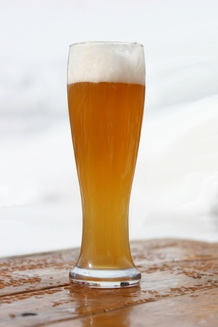
In the last section we focused on the different ways to operate and maintain a variety of bulk beverage dispensing units, with a focus on spirits, wine and soft drink systems.
This section will focus on beer dispensing systems.
Beer dispensing systems, especially draft taps are so commonly found in all establishments that we assume it must be relatively simple to keep and serve beer this way.
But behind the simple flick of a handle that sends beer streaming into our glass at the bar you’ll find systems that require precise design, exact operating conditions and careful, regular maintenance to ensure the proper flow of high-quality beer.
Main components of a beer dispensing system
Three main components of a beer dispensing system are:
- Gas
- Beer
- Cooling.
Gas
Draft systems either use CO₂ alone or CO₂ mixed with nitrogen in varying proportions depending on the requirements of the system and the beers being served. When properly selected and set, dispense gas maintains the correct carbonation in the beer and helps to preserve its flavour.
In most draft systems, the dispense gas also propels beer from the keg to the faucet. Because the dispense gas comes into direct contact with the beer, it must meet strict criteria for purity. And because of the damage it does, compressed air should never come in contact with beer.

Beer
Most draft systems use the gases mentioned above to drive beer from the keg, through tubing and to the faucet where it will flow into the customer’s glass. During the journey from keg to glass, we want to protect the beer from anything that would compromise its flavour or alter the carbonation created by the brewery.
The beer should flow through proper beer lines and avoid any contact with brass parts that would impart a metallic flavour. We also want the beer to flow at a specific rate and arrive with the ideal carbonation level.
The key to getting this all right is balance between the applied gas pressure and the resistance provided by the tubing and fixtures the beer passes through during its journey to the bar.
Cooling
The cooling system should hold beer at a constant temperature from keg to glass. Any change between the temperature of the cooler and the temperature of the beer leaving the faucet leads to dispense problems such as foaming.
In a simple direct-draw system a refrigerated cabinet maintains the temperature of the keg and provides cooling to the beer as it travels the short distance to the faucet.
Many long-draw systems use a walk-in refrigerator to cool the kegs, plus chilled glycol that circulates in tubes next to the beer lines all the way to the faucet, to ensure that the beer stays cold all the way to the glass.
For each beer dispense system, suitable equipment and designs must be chosen for each of these three components—gas, beer and cooling.
Beer systems equipment
Beer dispensing systems normally comprise nine key components:
- Refrigeration/Cooling
- Keg
- Coupler
- Beer Line
- Faucet
- Gas Source
- Regulator
- Gas Line
- Tailpieces and Connectors.

Refrigeration/Cooling
Consistent and controlled beer dispense requires that the beer travelling from keg to glass be maintained at a temperature of 1.1° to 3.3°C. While temporary service may employ ice for cooling, most permanent installations employ refrigeration systems.
Cold box refrigeration systems
Cold box refrigeration systems can provide cooling for a small direct-draw box cooler or a large walk-in.
The refrigeration itself can either be self-contained with the compressor and condenser mounted on the unit or with a remotely mounted compressor and condenser.
Remotely mounting the compressor can benefit t the installation by removing the source of heat from inside a room or building; however, this requires additional refrigerant piping and possibly higher cost.
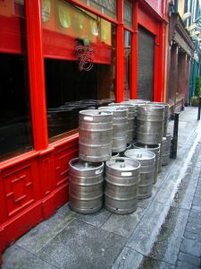
Condenser cooling
Condenser cooling can utilise either air or water.
Kegs
Kegs enable beer transport and dispense while maintaining its quality and integrity. Their design protects beer from both air and light while enabling easy and rapid dispense.
Most brewers use kegs made of stainless steel, but you also see rubber-coated, aluminium, steel and recently plastic kegs in the marketplace.
When tapped, the keg’s valve admits gas to the head space where it applies the pressure needed to push beer up through the spear or down tube and out of the keg.
Older keg designs, although rarely encountered, utilise different tapping methods not covered here.
Keg sizes vary from approximately 5 to 15.5 gallons. (18- 60 litres)
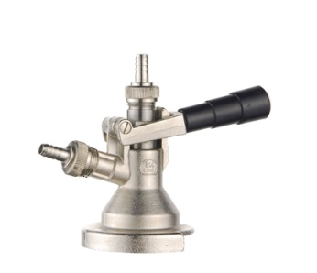
Coupler
Gas flows in and beer flows out of a keg through the coupler.
When you attach a coupler to a keg to tap it, a probe on the bottom depresses the keg valve (or ball) and allows CO₂ to enter the keg and apply pressure to the beer. This forces the beer to travel up the down tube (spear) and drive the beer to the faucet.
Line
Between coupler and faucet, beer travels through beer line selected to fit the needs of the specific draft application.
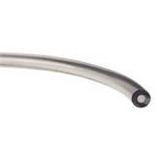
Options range from vinyl to specialised barrier tubing and even stainless steel.
Most draft systems use clear vinyl tubing for all or part of the beer line. In picnic and direct-draw systems, beer often runs most or the entire route from coupler to faucet in vinyl tubing. In long-draw systems, beer commonly passes through two sections of vinyl hose but travels most of the way in special barrier tubing.
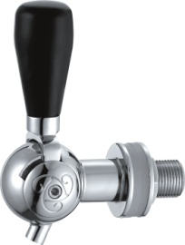
Faucet
Faucets dispense beer to the glass. They also hold the tap marker to identify the type of beer being dispensed. The most common faucets are generally suitable for dispensing both ales and lagers.
Gas Source
Beer systems depend on gas pressure to push beer from the keg to the faucet. To achieve this, kegs should be pressurised with carbon dioxide, or a carbon dioxide and nitrogen mix.
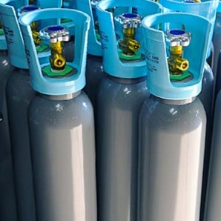
Gas selection and purity affect the freshness and quality of the beer served through the draft system.
Remember: The gas you use fills the keg as the beer drains. Thus, off-flavours or impurities in the gas quickly migrate to the beer to spoil its freshness and flavour.
Compressed air should never be used to pressurise a keg as the oxygen in the air generates stale flavours in beer within just a few hours.
Gas Line

Gas line should be selected to withstand the pressures expected in the draft system. We saw that vinyl tubing often serves as beer line and vinyl of some type often serves as gas line.
Often vinyl gas line has greater wall thickness than vinyl beer line. To help distinguish between gas line and beer line, coloured vinyl is used for CO₂ supply lines in some systems.
But clear vinyl may be used as it aids in troubleshooting by allowing you to see if beer has escaped the coupler and entered the gas line due to a faulty or missing Thomas valve.
Regulator
A regulator adjusts and controls the flow of gas from any source. Each regulator typically has at least one and often two pressure gauges that help in setting pressures and monitoring gas levels. Valves and an adjustment screw control the actual flow of gas from source to destination.
All gas systems employ a primary regulator attached to the gas source, namely a portable bottle or bulk tank. This regulator typically contains two gauges:
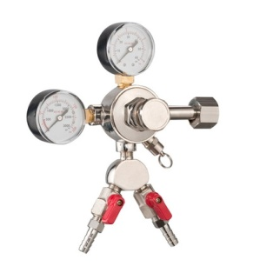
- One high-pressure showing the tank or supply pressure
- A second low or regulated pressure gauge showing what is being delivered to the keg.
Regulators are attached to the gas bottle with either an integrated “O” ring seal in the face of the regulator fitting, or a fiber or Teflon flat washer. These parts need to be replaced occasionally to prevent leaks and should be inspected every time the bottle is changed.
Many regulators are also equipped with one or more shut-off valves located on the low-pressure outlet, allowing the CO₂ to be shut off without changing the set-screw or shutting off the main tank valve.

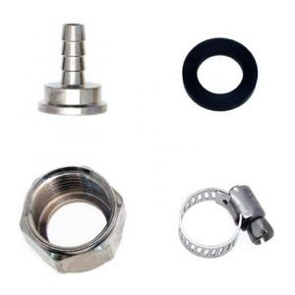
Tail Pieces and Connectors
Tail pieces connect couplers, wall bracket, shanks or any other piece of equipment to vinyl tubing or other types of beer line. Chromed brass and stainless steel tail pieces come in several sizes to match common tubing diameters. They are held in place with a nut and sealing washer. A clamp secures the tubing to the tailpiece on the barbed side. A nut and sealing washer attach the tailpiece to the coupler or other equipment on its flat side.
Handling kegs
The correct handling of kegs plays an important role in the ability to serve quality beer.
This includes the need to chill kegs and to link kegs in a series.
Cold Storage and Proper Chilling of Kegs before Serving
Warm kegs cause more problems at the tap than nearly any other issue.
To ensure fresh flavour and ease of dispense, draft beer should remain at or slightly below 38°F (3.3°C) throughout distribution, warehousing and delivery.
At retail, even a few degrees increase above the ideal maximum of 38°F (3.3°C) can create pouring problems, especially excessive foaming. Ideally all draft beer delivered to retail will be stored cold until served.
Linking Kegs in Series
Busy establishments may connect kegs in a series or in a chain to meet peak capacity demands. Chaining two or three kegs of the same product together allows all of the chained kegs to be emptied before beer stops flowing.
The first keg in the series will be tapped with a normal coupler.
The second (and subsequent) kegs in the series require that the Thomas valve be removed from the gas side of the coupler.
Tap the first keg with the normal coupler. Instead of sending the beer line from this first coupler to the bar faucet, connect it to the CO₂ inlet on the second keg’s coupler.
Subsequent kegs can be attached the same way.
When pressurised and pouring, beer flows from the first keg to the second and on to the third before it travels to the faucet. Once set, this arrangement will pour the contents of all the chained kegs before it runs empty.
A series arrangement should only be used in establishments that will “turn,” or empty kegs rapidly. The establishment needs to completely empty the entire series on a regular basis. Failure to empty the series completely leaves old beer in the system.

Handling glassware
Properly designed and appropriately operated, your draft system pours perfect draft beer from its faucets.
But the consumer’s experience can still be ruined by improper pouring, glass residue and unsanitary practices.
Glassware Cleaning
A perfectly poured beer requires a properly cleaned glass. As a starting point, glassware must be free of visible soil and marks.
A beer-clean glass is also free of foam-killing residues and lingering aromatics such as sanitiser.
A freshly cleaned glass should be used for every pour. It is recommended that a used glass never be refilled.
Handling Clean Glasses
Keep glassware clean and odour free after washing:
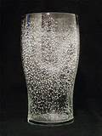
1. Air-dry glassware. Drying glasses with a towel can leave lint and may transmit germs and odours
2. Dry and store glasses in a stainless-steel wire basket to provide maximum air circulation. Similar deeply corrugated baskets or surfaces also work
3. Do not dry or store glassware on a towel, a rubber drain pad or other smooth surface, as they can transfer odours to the glass and slow the drying process
4. Store glassware in an area free of odours, smoke, grease or dust.
Glassware Temperature
Serving between 38º to 44ºF (3.3 – 6.6 °C) delivers the best taste experience for most beer styles. Domestic lager beer can be enjoyed at 38º to 40ºF (3.3 – 4.4 °C) if served in a chilled glass. Beer served at near-frozen temperatures retains more CO₂ gas (resulting in a more filling experience for the consumer) and blinds the taste experience (taste buds are “numbed,” resulting in a bland taste experience) in comparison with beer served at recommended temperatures.
Room temperature glasses are preferred for craft beer but may cause foaming on highly carbonated beer.
Chilled glasses are preferred for domestic lager beer, but they should be DRY before chilling.
Wet glassware should not be placed in a freezer or cooler as it may create a sheet of ice inside the glass.
Frozen glasses will create foaming due to a sheet of ice being formed when the beer is introduced to the glass. Extremely cold glass surfaces will cause beer to foam due to a rapid release of CO₂ from the product.
Water mist devices may be used to pre-wet and chill the glass interior prior to dispense.
Glass interior should be mostly free of excess water before pouring.
Connecting draft beer
The first steps when connecting the draft beer are to:
- Turn on temprites - never have water in the line when turning on temprites as the water can freeze, block the flow of beer and potentially split the lines)
- Drawing beer through to taps
- Test for quality.
Different requirements apply where python/glycol systems are in use.
Pouring draft beer
Proper serving of draft beer is intended to have a “controlled” release of carbonation to give a better tasting and sensory experience. The evolution of CO₂ gas during pouring builds the foam head and releases desirable flavours and aromas.
Technique
1 Hold glass at 45º angle, open faucet fully
2 Gradually tilt glass upright once beer has reached about the halfway point in the glass
3 Pour beer straight down into the glass, working the glass to form a one inch collar of foam (“head”). This is for visual appeal as well as carbonation release
4 Close faucet quickly to avoid wasteful overflow.
Pouring Hygiene
- In no instance should a faucet nozzle touch the inside of the glass. Nozzles can potentially transfer germs from one glass to another
- In no instance should the faucet nozzle become immersed in the consumer’s beer. Nozzles dipped in beer become a breeding ground for microorganisms
- Importance of one-inch foam collar. While retailers struggle with customers who demand their beer “filled to the rim,” brewers prefer beer poured with about a one-inch collar of foam (“head”)
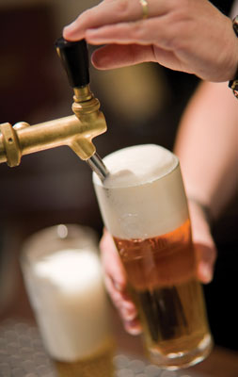
- A one-inch head maximises retailer profit, as foam is 25% beer. Filling glass to the rim is really over pouring
- A proper head on a draft beer delivers the total sensory experience, including the following sensory benefits:
- Visual appeal of a good pour
- Aromatic volatiles in beer released
- Palate-cleansing effect of carbonation enhanced
- Textural and sensorial qualities of beer better presented to consumer.

Beer system maintenance and cleaning
These guidelines reflect the key actions needed to maintain draft systems and pour trouble-free high-quality beer.
Before performing these actions, please read equipment manuals as they contain many details important to effective and successful cleaning.
Cleaning Frequency and Tasks
Every two weeks (14 days)
- Draft lines should be cleaned
- All faucets should be completely disassembled and cleaned
- All keg couplers or tapping devices should be scrubbed clean.
Quarterly (every three months)
- Draft lines should be de-stoned quarterly with an acid line cleaning chemical or a strong chelator in addition to the regular caustic cleaning
- All FOB-stop devices (a.k.a. beer savers, foam detectors) should be completely disassembled and hand detailed (cleaned)
- All couplers should be completely disassembled and detailed.
Cleaning a draft beer system
It is important to clean your machines and system after every batch of beer you use. If you don't, you can ruin future batches of beer. Cleaning a draft beer system is easy with the proper supplies.
Foamy beer can be caused by the build up of bacteria, yeast or mould within a beer line. Dirty beer lines can affect the quality and taste of beer, so it is important to regularly clean beer lines. This task can easily and quickly be done with a pressurised cleaning bottle and the right chemicals.
Steps to cleaning beer lines
- Disconnect all parts and flush the beer lines with water using the pressurised cleaning bottle to release any remaining beer
- Fill the pressurised cleaning bottle with the cleaning solution mixed with water. You can use a line cleaner that is either caustic with a high pH, or acidic with a low pH depending on the condition of the lines and the type of system being cleaned. Check the directions on the solution to see how much water is needed per solution mix
- Push the solution/water mix into the lines and allow soaking for approximately 10 minutes. Be sure to check the directions for the chemicals as soak times may vary
- Flush the lines thoroughly with clean water to remove the cleaning chemicals. Once the solution has been flushed, check the pH level with a pH tester or litmus paper to be sure that all evidence of cleaning solution is gone
- Remove the keg coupler and faucet and soak in water with a cleaning chemical. Use a brush to clean the items, and then rinse well with water
- Reconnect all parts and run some beer through the faucet to check flow. Discard beer and be sure all the lines are refilled with beer.

Identifying and rectifying problems with beer dispensing system
All draft beer systems will eventually need maintenance. Clogged lines, low CO₂ tanks or broken taps can greatly affect properly pouring beer, flavour and foam content. These problems, if not fixed quickly, can easily turn your patrons away to another bar. Learning how to properly troubleshoot your draft beer system will ensure that your customers keep coming back to your establishment. Troubleshooting will also aid in keeping your draft beer system in good working order.
Types of common faults and remedies
Slow dispense at tap
- Ensure dispense tap is working properly
- Ensure sparkler is not too tight or blocked
- Ensure lines are clean
- Ensure gas cylinder is not empty.
No dispense at tap
- Ensure dispense tap is working properly
- Ensure sparkler is not too tight or blocked
- Ensure keg is not empty
- Ensure line primer filled with beer
- Ensure ball is floating
- Ensure coupling head is fitted correctly
- Change the keg.
Activities to identify and rectify problems
- Check the keg first if you notice a problem with the beer as you pour it from the tap. If the tap starts to sputter or barely pour out, chances are your keg is near empty and must be changed
- Notice the flow of the beer when you pull on the tap handle. If the beer is barely pouring out, the main valve could be partially closed. If the beer pours out too fast, then the valve might be open too wide. If adjusting the valves has no effect, then your draft lines could be clogged or have air bubbles blocking the flow. This will require professional maintenance
- Check the gauge on your CO₂ tank. If the gauge reads lower than normal, your beer will have little foam and will not taste as it should. You should change the CO₂ tank at this point
- Notice the level of foam pouring out of the tap. If the glass is full of foam, then the keg might be near empty, or the CO₂ level could need adjustment. Try closing the CO₂ valve on the tank and then open it to halfway, let the beer run momentarily and see if the foam stops pouring out
- Taste the beer for correct temperature. If the beer is too warm or has a heavy foam or "head," your refrigeration system could need repairs
- Have your draft beer lines cleaned periodically to ensure proper taste and flow through the lines. Have your keg cooler checked for correct temperature and compressor maintenance to ensure that your draft system remains in working order.

2.2 Follow safety procedures regarding handling, connecting and storing of gas

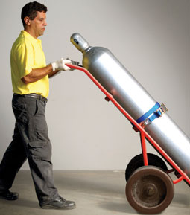
Introduction
Gas is a common and essential component of bulk dispensing systems. It is essential that when handling gas it is done so in a manner that is safe for the operator.

Knowledge of beverage gas system operations
Any cellar operator must have an understanding and working knowledge of not only the key components of beverage dispensing systems, as identified to date, but also of beverage gas system operations.
This includes knowledge of, but not limited to:
- How to handle, store, connect and disconnect beverage gas cylinders (including different types of cylinder systems and different types of gas)
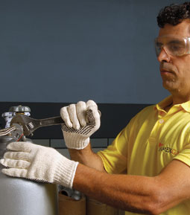
- Inert gas in confined spaces and the potential dangers
- Particular dangers of carbon dioxide and nitrogen
- Required fire protection equipment and other emergency and alarm procedures
- Methods and techniques for undertaking routine checks for leaks. (including monitoring of regulators, drop tests, spray tests, disconnecting and re-connecting leads)

Assess your cellar to identify safety hazards
- Minimise risks by only allowing trained personnel into your cellar
- Display clear warning signs that detail safety measures
- Make sure the cellar is sufficiently ventilated
- Leaks from cylinders or hoses in confined spaces can deprive the atmosphere of oxygen, resulting in serious injury or death. Safe systems of working identify all the hazards and ensure that the necessary controls are in place. Also, a CO₂ sensor will detect the presence of carbon dioxide for the protection of personnel.

Prevent build up of CO₂
Breathing high concentrations of CO₂ can be deadly!
Take care to prevent CO₂ build-up in enclosed spaces such as cold boxes. System leaks or beer pumps using CO₂ can cause this gas to accumulate in the cooler. To prevent this, beer pumps driven by CO₂ must be vented to the atmosphere.
CO₂ warning alarms are available and recommended for installations with enclosed areas such as cold boxes containing CO₂ fittings and gas lines.

Never tamper with cylinders
- Only properly trained personnel should handle compressed gas cylinders
- Only connect gas cylinders to primary regulators
- Be aware that cylinders can become flying objects when cylinder valves are damaged or broken off
- Always place valve protectors on gas cylinders when cylinders are not connected for use and are not empty
- Never try to unscrew a cylinder’s valve fitting.

Store cylinders correctly
- Gas cylinders must be secured at all times to prevent tipping. Do not stand cylinders on uneven floors
- Use appropriate material such as chain or plastic coated wire cable to secure cylinders whether they are full or empty
- Store cylinders in an upright position whenever possible
- Do not expose cylinders to direct heat, sunshine or high temperatures
- Gas cylinders must not be stored in public hallways or other unprotected areas
- Cylinders must be protected from damage. Do not store cylinders where heavy objects may fall on them.

Handle cylinders correctly
- Cylinders must be handled and stored in accordance with local laws
- Never drag, slide or roll cylinders. Carry cylinders using the handle or even use a cylinder trolley. Do not lift cylinders above chest height
- Do not drop cylinders, strike them against each other or against other surfaces violently
- Do not use the valve cover to lift cylinders as this could become unattached. If the cylinder is dropped on a hard surface, it could cause an explosion
- Do not force connections that do not fit
- Do not directly handle a frosted cylinder.

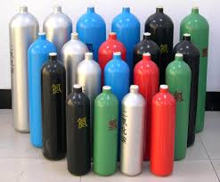
Do not overstock
- Overstocking increases the safety risk to your premises and your personnel
- Calculate your cellar gas consumption and keep the minimum required to last you until your next delivery.

Work Projects
It is a requirement of this Unit you complete Work Projects as advised by your Trainer. You must submit documentation, suitable evidence or other relevant proof of completion of the project to your Trainer by the agreed date.
2.1 To fulfil the requirements of this Work Project you are asked to research, identify and either explain or demonstrate usage of a beer dispensing systems including:
- Common equipment used in a beer system
- How to pour draft beer
- How to identify faults with equipment and possible remedies
- How to maintain clean beer related equipment.
2.2. To fulfil the requirements of this Work Project you are asked to explain how to safely handle, use and store gas in a cellar.

Summary

Operate and maintain beer reticulation systems
Operate and clean beer reticulation systems in accordance with manufacturer’s instructions
Main components of a beer dispensing system
Beer systems equipment
Handling kegs
Handling Glassware
Connecting draft beer
Pouring draft beer
Beer system maintenance and cleaning
Cleaning a draft beer system
Identifying and rectifying problems with beer dispensing system.
Follow safety procedures regarding handling, connecting and storing of gas
Knowledge of beverage gas system operations
Assess your cellar to identify safety hazards
Prevent build up of CO₂
Never tamper with cylinders
Store cylinders correctly
Handle cylinders correctly
Do not overstock.

Element 3:
Use and maintain refrigeration systems

3.1 Measure refrigerator temperatures accurately and adjust correctly to comply with product requirements

Introduction
A refrigerator is a common bar appliance that consists of a thermally insulated compartment and a heat pump (mechanical, electronic, or chemical) that transfers heat from the inside of the fridge to its external environment so that the inside of the fridge is cooled to a temperature below the ambient temperature of the room.
A refrigerator maintains a temperature a few degrees above the freezing point of water. Optimum temperature range for food and beverage storage is 3 to 5°C (37 to 41°F).

Types of refrigeration systems
As can be seen in this manual to date, the traditional refrigerator is not always required to keep beverages at the optimal temperature. A variety of systems can be used.
Refrigeration systems may include:
- Glycol system or refrigerated beer line system
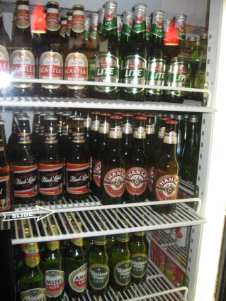
- Glycol tanks and pumps
- Compressors
- Chiller plates
- Cold rooms
- Cabinets
- Instantaneous coolers
- Portable coolers
- Ice bank or water chilled system
- Temprite or instantaneous cooler system.
All of these systems serve a purpose of keeping beverage items at an optimal cool temperature.
Some of these systems have been discussed in previous sections of the manual.
This section will explore the concepts of commercial refrigeration cabinets.

Commercial bar refrigerators
These are the most commonly used refrigeration equipment.
These are pieces of equipment where bottled and canned bar stock, milk, soft drink, fruit, water is stored behind the bar.
These cabinets can be fully self-contained (that is, the motor is part and parcel of the unit itself), or run by a compressor unit which is located outside the establishment well out of the way of prying eyes and interfering fingers.
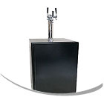
Types of commercial bar refrigerators
Kegerators
Kegerators are a self-contained beer dispensing unit. Kegerators are commonly referred to as “Direct Draw” dispensing; the keg is located within 5’ of the faucet.
Back Bar Refrigerators
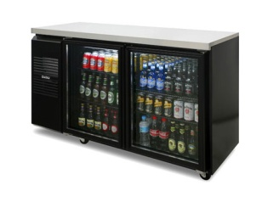
These are common pieces of equipment at bars which keeps your foods and beverages at the perfect temperature and provides ample storage for canned and bottled beverages.
Back bars look similar to kegerators except they do not include any tapping equipment or stainless countertops. The refrigeration is used for extra keg storage, bottles and cans.
Shallow and Deep Well Bottle Coolers
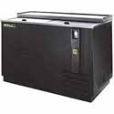
Bottle coolers have slide back tops for easy access to cold bottles and cans.
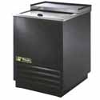
Bottled beverages can be rapidly chilled and ready to serve in little time at all. This equipment features a forced air refrigeration system designed to chill and hold products between 32°F and 38°F, cold enough to cause the bottle to frost over w hen removed from the cooler. Foamed-in-place polyurethane insulation helps to provide maximum operating efficiency.
Glass Frosters / Chillers
Commercial glass frosters are equipped with a balanced refrigeration system that rapidly chills mugs to minus 10°F, cold enough so that frost forms on the glassware when removed from the unit.
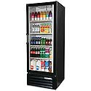
Merchandise / Display fridges
These fridges make an excellent display of cold bottle and can beverages for sale, allowing customers to service themselves.
Walk in Coolers
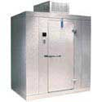
This equipment is used in high volume or remote establishments and is a one piece refrigeration system with condenser, coil and condensate evaporator.

Methods to check refrigeration temperatures
Measuring the temperature can help determine if the refrigerator is working properly. Before getting started, remember that the frequency of door openings plays a large role in maintaining proper refrigerator temperatures
There are two ways to check the temperature inside a refrigerator:
- One way checks the air temperature inside the refrigerator
- Another way gives the internal temperature of something in the refrigerator.
Make thermometers easy to read and place them near the front. A refrigerator manufacturer suggests putting a thermometer in a glass of water. Check the temperature on first opening after the door has been closed at least eight hours. In this way, you are checking the temperature of something in the refrigerator, rather than the air inside the refrigerator. To adjust a temperature, adjust one control, and then wait 24 hours to take a reading.
Types of commercial refrigerator thermostats
Commercial refrigerator thermostats measure and regulate the temperature in large commercial refrigerators. They do this by opening and closing an electric current that turns the refrigerator's compressor on and off.
When the compressor is on, the temperature inside the refrigerator drops; when it is off, the temperature inside the refrigerator rises toward the ambient external room temperature.
By turning the compressor on and off at the correct times, a thermostat causes the compressor to maintain a specific temperature inside the refrigerator.
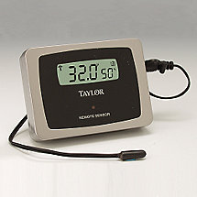
Air Sensing
- Air-sensing thermostats comprise the majority of thermostats in commercial refrigerators. The thermostats measure the return air in the refrigerator, which refers the average temperature in the refrigerator; it is distinguished from the supply air
- Air-sensing thermostats use a straight, liquid- or gas-filled capillary attached to a bulb whose pressure varies with the temperature, opening and closing an electric current to turn the refrigeration unit on and off
- As with evaporator coil sensing thermostats, the sensor is located inside the evaporator housing, in a tube at the front of the evaporator.

Evaporator Coil Sensing
- An evaporator-sensing thermostat measures the temperature of the refrigerator's evaporator coil, rather than that of the air. This can be helpful in cases where the temperature in the refrigerator suddenly rises and causes the compressor to overcompensate so that frost forms on the evaporator coil
- Air-sensing thermostats would not register the frost build-up and would therefore allow the overcompensating compressor to continue operating, but a sensor measuring the temperature of the evaporator coil itself would deactivate the compressor until the frost on the evaporator coils dissipates. The capillary tube sensor in evaporator coil-sensing thermostats coils into a spiral next to the evaporator.

Pressure Sensing
- Pressure control thermostats differ from air-sensing and evaporator coil-sensing thermostats in that they are located outside the evaporator housing near the compressor
- Commercial refrigerator units use a refrigerant fluid to remove heat from inside the refrigerator, lowering the temperature. The refrigerant fluid circulates between the compressor and the evaporator at a specific pressure, and the pressure correlates to the resulting temperature inside the refrigerator
- Low-pressure control thermostats measure the pressure of the refrigerant to indirectly measure and control the temperature in the refrigerator.

3.2 Clean and maintain refrigerator components

Introduction
Commercial refrigerators are an essential part of any bar operation.

In the previous section a number of refrigeration systems were identified. Regardless of the equipment being used it is essential that they are cleaned properly and correctly after specific definite intervals of time.
All aspects of the unit need consideration.
Given that some fridges in a bar will contain food and beverages, they must be treated like any commercial refrigerator when it comes to cleaning.
The shelves placed inside the refrigerator must be cleaned at least once every week.
If not cleaned regularly, the commercial refrigerator may give out a foul smell. It may also lead to the growth of fungal and bacterial activity inside the refrigerator. Any such activity can prove to be very dangerous and fatal too, to persons who consume food or beverage products made from these. It may also adversely affect the flavour and smell of such food or beverage items.

Refrigerator components
Refrigerator components may need to be cleaned on a regular basis include:
- Vents
- Coils
- Filters
- Seals
- Catches.
General refrigeration cleaning activities
Since a refrigerator is an electrical unit before cleaning it, it is very important that it must be unplugged. Only after you have made sure that the plug of the refrigerator is removed from the socket and the switch is turned off should you commence the cleaning of the commercial refrigerator.
The basic component of a commercial refrigerator that needs cleaning is its exterior unit, door, the shelves, the door gaskets, the condenser coil and the motor or fan.

The exterior of the unit needs to be wiped every day. It must be cleaned at least once a week with water and mild soap solution. The use of strong cleaning lotions, bleach etc must be avoided because this may affect the surface of the refrigerator unit whereby it may lose its smooth finish. A mild soap and warm water solution will clean away any stains or dirt and dust. If the commercial refrigerator has a glass door then its cleaning is much simpler. It may be cleaned with a damp cloth or paper.
Shelves of the refrigerator too must be cleaned with warm water and mild soap solution to wipe away the dirt and the dust. Remember not to wash the shelves or the interior portions of the refrigerator with any strong solution and bleach because it will not only affect the finish of the refrigerator but also leave behind a strong odour.
Such strong odour if mixed with the food items stored in it will affect its flavour.
The door gaskets must be cleaned every week. To clean them you can soak them in soap and water solution for about thirty minutes. After that all that you need to do is dry them and reattach them back. However, you need to ensure that they form a proper seal after they have been reattached.
The condenser coil is the most important part of a commercial refrigerator; therefore, it must be cleaned with a lot of care. It needs to be cleaned every month with commercial condenser coil cleaner to keep it free from dust, dirt and lint of any kind. Similarly, the fan blades and the motor should be cleaned once a month with a dry cloth and soft brush.
If it is necessary to wash them with water, they need to be completely dry before the refrigerator is switched on to prevent a short circuit.

Cleaning a back bar
Business with commercial settings such as a restaurant, arena, stadium or bars should always keep the back bar refrigerators in excellent working condition.
Refrigerators and freezers should have their condensers cleaned every three to four months. This will help to keep their back bar refrigerators working efficiently and keep their equipment running longer and saving money on utilities.
Do not force your refrigerator to work harder than necessary by locating it near a heated source; such as heating vents, kitchen ranges or dishwashers; this will just make your back bar work harder than normal.
Do not suffocate a refrigerator by enclosing it tightly against multiple walls. It is also important to have at least two or three inches of air flow around the refrigerator. This will help keep your back bar refrigerator running more efficiently, which will save you more money.
Cleaning a back bar refrigerator is not as hard as most people would think it would be. Move the refrigerator out from the walls and vacuum their condenser coils once a year. This keeps the refrigerator working efficiently and helps control the right temperature. Refrigerators run much better for shorter periods with clean coils.
To be sure, forgetting to clean the coils of a refrigerator can be very costly. The good news is that there really is nothing to cleaning it yourself. First, be sure to move the refrigerator out from the wall and unplug it.
Second, you will need to remove the cover panel, which is not very hard to do. Then with a long, narrow nozzle of a vacuum cleaner just clean out all the dust and debris. Then just replace the cover and plug the refrigerator back in.
Also be sure to check the water drip pan in the back lower part of the refrigerator. Sometimes your drainage in the refrigerator can get clogged up. However, this is not hard to fix, just run some warm water through the tube to unclog and this should take care of this problem.
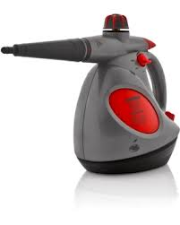
For cleaning the inside of the refrigerator make a solution of baking soda and water and place into a spray bottle for easier cleaning. Spray the solution all over the surfaces of the refrigerator and wipe clean inside and out.
One other solution to keeping your back bar refrigerators is to invest in a steam cleaner. Steam cleaners are a great way to clean back bar refrigerators, because it will remove dust mites, kill bacteria that builds up and removes dust, mould, and mildew. Steam vapour cleaners are considered environmentally safe cleaning systems.
Steam is a safe, chemically free cleaning and sanitising cleaning system. This tool is highly recommended for any business to keep their equipment running efficiently and safe.

3.3 Set or re-set walk-in alarms to manufacturer's specifications

Introduction
Given the substantial value often associated with bar stock it is not surprising some establishments will have refrigeration monitoring and control systems installed.
Whilst the main purpose of these systems is to prevent or deter theft, they do have many positive functions that may be appealing to cellar and bar operators.

Purpose of system products

These systems are designed to:
- Protect perishables
- Save energy
- Increase operator safety.
Types of system products
Products within these systems include:
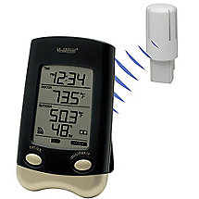
- Single and multipoint temperature alarms – this is important as it is vital that temperatures of food and beverage items remain within acceptable temperature ranges
- Web enabled data logging systems – records who enters fridges and at what time
- Door monitor and alarms – notifies when fridge doors are opened
- Panic (entrapment) alarms – commonly found in ‘walk-in’ fridges that notify the appropriate person when someone has been locked into a unit.

Follow manufacturer’s instructions
When an alarm has been set off, it is essential that the appropriate responses are taken in a timely manner.
Each equipment supplier will have set steps that should be taken in the event that alarms have been set off.
In the event that these steps are not readily available, each bar outlet should have policies and procedures to follow.

3.4 Recognise and repair/report basic mechanical faults in accordance with enterprise procedures

Introduction
It is a fact of life that any piece of equipment in a food and beverage business will have problems and performance issues to some extent.
It is how these problems are handled when they arise can not only limit the damage to product contained within, but the effects it will have on operations and costs of repairs.
Whilst it is not expected that a cellar operator will have an extensive understanding of how to fix commercial beverage refrigeration units, being able to recognise and report faults is a great start and will have a great positive impact.
Recognising basic mechanical faults
Compressor
The compressor increases or decreases the temperature and pressure of any air vapour entering the refrigeration unit. The model of commercial refrigerator you are working on determines how large the compressor is, and where it is located. If the refrigerator you are working on is not keeping things cold, or you do not hear any running action, it is possible that the compressor is not working.
Check the temperature of the compressor itself. If it is incredibly hot, then there may be a problem with it. Listen to hear whether it is running. If it is running, you may hear the sound of the compressor whirring hard, like a motor trying to start, then the sound cuts out. This means the compressor motor is faulty.
Fluctuating Temperature
There are a few reasons why a commercial refrigeration unit does not maintain a consistent temperature. You should check to make sure that all the operation temperatures; subheating and subcooling are well within the normal range specified in your operating manual.
If they are not within the normal range, check that the temperature controls are turned down to a cold, if not the coldest, setting. If the temperature controls are turned all the way down, and it is not turning the compression off, then the temperature controls have failed and will need to be replaced.

Fans
For almost any troubleshooting situation with a commercial refrigerator, you should check to make sure the fans of the fridge are working. Fans help regulate the temperature of components inside the refrigerator, so if they are faulty, the unit may run hot, or not run at all.
As soon as you start working on the fridge, make sure the fans are running. If they are not, make sure the fans are clean and free of debris. Check to make sure that all the wiring going to the fans is in good working order and that there is no visible wire damage. You can use a voltage-reading device to make sure the fans are receiving power.
Also, make sure the fans are running in the correct direction, as specified in your operations manual. If the fans are not working on your fridge, it can cause the compressor and other components to work too hard, causing them to wear out early. Check the fans regularly for correct operation.
Reporting basic mechanical faults
When mechanical faults have been recognised it is essential that they are reported immediately to the most appropriate person.
This may be:
- Bar supervisor
- Bar Manager
- Maintenance Department.
Options in reporting mechanical faults
Options in reporting mechanical faults include:
- Speaking face-to-face with the Manager or maintenance department
- Using other internal communication methods (pager, mobile phone) to contact and notify directly either the maintenance department
- Completion of a Maintenance Report identifying the faulty item, the location, your name, and the nature of the problem.

Work Projects
It is a requirement of this Unit you complete Work Projects as advised by your Trainer. You must submit documentation, suitable evidence or other relevant proof of completion of the project to your Trainer by the agreed date.
3.1 To fulfil the requirements of this Work Project you are asked to research and identify:
- Types of refrigeration systems
- Commercial bar refrigerators
- Methods to check refrigeration temperatures
- Types of commercial refrigerator thermostats.
As part of this exercise you must conduct internet research and identify and cost the above mentioned equipment for a standard bar operation, including identification of possible suppliers in the immediate region.
3.2. To fulfil the requirements of this Work Project you are asked to research and identify the steps associated with cleaning bar refrigerators including cleaning products and equipment needed to complete these cleaning activities.
3.3. To fulfil the requirements of this Work Project you are asked to research and identify different alarm systems used in bar refrigeration systems. Please identify different types of systems and possible suppliers in the immediate region.
3.4. To fulfil the requirements of this Work Project you are asked to research and identify common problems associated with refrigeration systems and how these problems can be rectified.

Summary

Use and maintain refrigeration systems
Measure refrigerator temperatures accurately and adjust correctly to comply with product requirements
Types of refrigeration systems
Commercial bar refrigerators
Methods to check refrigeration temperatures
Types of commercial refrigerator thermostats.
Clean and maintain refrigerator components
Refrigerator components
General refrigeration cleaning activities
Cleaning a back bar.
Set or re-set walk-in alarms to manufacturer's specifications
Purpose of system products
Types of system products
Follow manufacturer’s instructions.
Recognise and repair/report basic mechanical faults in accordance with enterprise procedures
Recognising basic mechanical faults
Reporting basic mechanical faults
Options in reporting mechanical faults.

Element 4:
Monitor quality of cellar products

4.1 Test regularly quality of cellar products and identify faults

Introduction
In this manual to date, we have identified pieces of equipment commonly used in cellar operations and how to correctly operate and maintain them for optimal performance.
Whilst it is important to ensure equipment is working effectively, it all amounts to nothing if the end product is not as it should be.
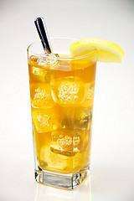
It is important to regularly test the quality of the end product of products and try to find solutions to the fault in a timely manner.
As a reminder cellar products may include:
- Beers
- Spirits
- Wine
- Post-mix syrups.
This section will explore some of the common faults with the end product and possible solutions to solve these faults.
Beer – faults and remedies
There are three main faults that are associated with the end product. Following are identification of these faults and possible remedies.
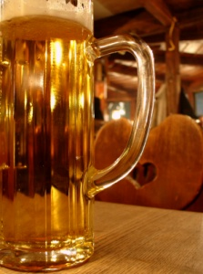
Cloudy beer
- Cleaning lines every week
- Ensure keg is still within ‘best before date’
- Flush through lines with water
- Connect to a new keg.

No head on beer
- Ensure staff are trained in pouring
- Ensure tap sparkler is in place
- Ensure beer tap is being used correctly
- Ensure correct glass cleaning techniques are used.
Beer fobbing in glass
- Ensure beer is poured at correct angle
- Ensure beer is at correct temperature.
Spirits – faults and remedies
The main faults for spirit dispensers in relation to the final product include:
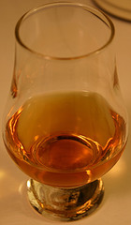
Strength of spirit
- At times the amount of spirit being dispensed may be more or less than what is required. Check the equipment.
Strange taste
- The dispenser may have been used for another bottle of alcohol. It must be cleaned correctly.
Beverage taste soapy
- It is important to ensure that it is cleaned properly.
Wine – faults and remedies
It is important to note that these problems are normally associated with bulk wine dispensing units and differ to the problems normally associated with bottles wine.
Cloudy or scaly wine

- Cloudy or scaly wine is always a symptom of a dirty system and poor maintenance. Incorrect machine use may also contribute to this condition.
Wine smell or taste bad
- New units may cause some wines to have a slightly different taste or smell. This is normal and will diminish very rapidly. It should disappear completely within 1-3 days.
Wine is going off quickly
- Wines are expected to last approximately one to three weeks. Therefore it if the problem occurs before this time it will vary based on a number of factors being temperature, wine age and wine type, and cleanliness of the machine.

Post mix – faults and remedies
The main problems associated with post mix systems in relation to the end product include:
Product is flat
- Check CO₂ levels to ensure carbonation is taking place.
Product is warm
- Check refrigeration system.
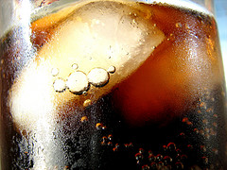
Product is flavourless
- Ensure the syrup box contains syrup
- Ensure syrup is going through lines
- Ensure line connections are sealed
- Ensure line is connected to syrup box.
Wrong product is being dispensed
- Ensure lines are connected to correct syrup box.
Importance of glassware
Quite often many problems relating to the appearance and taste of finished products are directly related to the condition and cleaning procedures towards glassware and not the equipment itself.
Sanitising glasses in a bar can be somewhat challenging, since even unseen residue from soap or beverages can leave an unsavoury taste in beverage as well as an unappetising film on glasses.
By cleaning bar glasses properly will ensure that no residue or grime is left in the glass, which can leave the beverage tasting less than ideal.
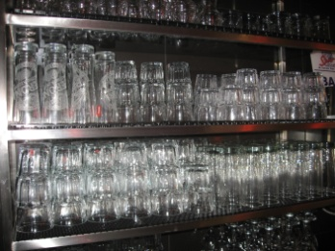
It should be noted that bar glasses should not be cleaned with commercial dish washing detergents because many of them are petroleum based and leave a thin film that cannot simply be rinsed off.
Most high volume outlets will have dedicated glass washing machines. Is an establishment does not use this equipment; the following steps may be useful.

Steps to cleaning bar glassware
- Empty out the contents of the glass. Rinse it briefly with warm water to remove any traces of the beverage
- Moisten a soft cloth with water and wring it out well. Sprinkle a moderate amount of baking soda onto the cloth
- Wipe down the inside and outside of the dirty glass with the cloth and baking soda. Make sure to wipe thoroughly around the rim. If the glass is tall and you cannot fit your hand down into the glass, use a baby bottle brush and a little bit of baking soda to scrub the bottom of the glass
- Rinse the glass under cool running water. Sit the glass in a sink drainer to dry. Avoid drying with a cloth or you risk leaving lint residue from the rag inside of the glass
- Glasses, especially wine glasses, may be polished.

4.2 Make adjustments within scope of individual responsibility or report faults to the appropriate person or people

Introduction
Given that many bars are involved in high volume operations, if a problem occurs, it can affect many customers and greatly impact on potential revenue that can be earned in an establishment.
Whenever a problem exists it is imperative that they are reported to the appropriate person in a timely manner.
Reporting cellar related faults
As with the reporting of mechanical faults, it is essential that they are reported immediately to the most appropriate person.
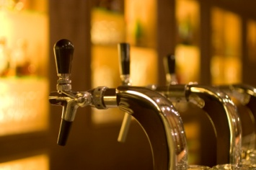
This may be:
- Bar supervisor
- Bar Manager
- Maintenance Department.
Options in reporting cellar related faults
Options in reporting cellar related faults include:
- Speaking face-to-face with the Manager or maintenance department
- Using other internal communication methods (pager, mobile phone) to contact and notify directly either the maintenance department
- Completion of a Maintenance Report identifying the fault, the location, your name, and the nature of the fault.

4.3 Use bin and keg card systems to assist in monitoring the quality of products and controlling stock

Introduction
Like in any high volume bar establishment, the enormous volumes of alcohol and the value attached to them is a considerable and important asset that must be monitored and controlled to ensure that the beverage items are correctly:
- Identified
- Stored
- Used before expiry dates.

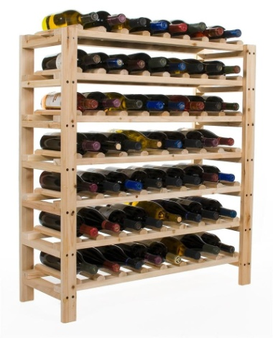
Aim of bin and keg key systems
The overriding aim of bin or keg key systems is to easily identify when an item or collective of items were purchased and to track their usage in an establishment.
A poor beverage inventory will lead to beverage wastage and loss as much as poor storage conditions or faulty dispensing equipment.
Bin cards are normally associated with individual beverage bottles in storage. The most common type of beverage which uses a bin system is wine. Given the endless makes, styles and vintages of wine, there needs to be a system which can easily identify bottles or batches of wine purchases.
Quite often a bin system incorporates inventory software and recording systems and the use of ‘identification’ tags placed around the necks of wine and other beverage bottles or on boxes of product. This ensures each bottle or box is traceable.
The unique bin number/s on each bottle neck tag / box allows every bottle or box to be found with ease and removed with accuracy.
Keg key systems are used to identify and record beer kegs. Given that beer kegs have a limited shelf life, however look the same, there must be a way to identify individual kegs.

Benefits of bin and keg key systems
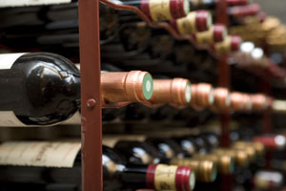
There are many benefits of using these ‘identification’ systems including:
- Easier identification of similar bottles, especially those from different vintages
- Easier to track volume of items
- Tracks actual consumption
- Ensures greater control of inventory
- Ensures appropriate stock location
- Identify how long they have been in stock
- Identify when they should be used – it helps to track the best time to drink beverages, especially wine bottles
- Helps facilitate stocktaking
- Helps enable accurate accounting records which identifies actual cost of goods sold.
Benefits of wine tagging systems
As mentioned before the controlling of wine bottle inventory is an important aspect of cellar operators. Using wine tagging systems means every bottle has attached to it a tag displaying a unique number and barcode. The tag allows a wine to be found with ease and is then held as evidence of opening. This allows a cellar operator to accurately maintain their cellar list.
Identify your wine locations
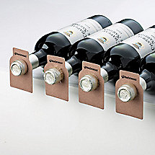
- Name your columns of racking or bins as 'locations', with each location holding between 50 and 100 bottles
- Cellar racking is often made up in columnar units of 8 or 10 bottles wide. Each of these columns may be identified as a single location. In wine cabinets each rack level may be identified as a location
- Providing an exact location for every bottle can cause chaos. When a wine is moved from one cell to another inadvertently, your computer will lose it forever.
Place your wines randomly
- Allows software systems to collate wines
- Trying to store wines in tag numeric order, will waste valuable storage space.
Reduce the search area
- You can halve the search area within a column location by placing whites at the bottom (cooler part) and reds at the top.
Finding select wine
- Let your software help you choose the wines to open
- Note the tag numbers of the wines which have been selected
- Go to the location, look in the appropriate area (red or white) and find each matching 3 digit number.
Maintaining an accurate inventory
- Ensure that every wine entering into a cellar is tagged and catalogued. Even casual drinking wines will be treated better, if they are tagged and properly selected for each occasion
- Avoid removing the tag from any bottle until it is opened, allowing identified wines to be returned to the cellar
- Accumulate used tags. Enter the tag number or scan the barcode to remove the wine from a cellar list.

4.4 Keep cellar tidy, clean and free from litter

Introduction
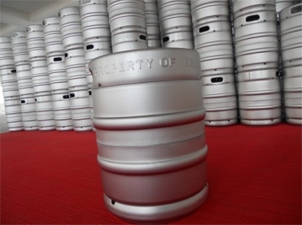
As a cellar contains beverages, it essentially must follow the usual hygiene requirements that apply to any food and beverage establishment or outlet.
It is essential that the cellar must fulfil modern health and safety regulations.
Not only is hygiene important, but by maintaining a well lit, ventilated and neatly stocked cellar can reduce accidents and other safety risks. It also enables you to work in a more efficient manner.

Cleaning and maintaining cellar area
There are a number of ways in which to clean and maintain a cellar area including, but not limited to:
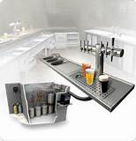
- Only keep items that are essential
- Remove used containers, boxes etc on a regular basis
- Store items in a logical manner
- Ensure a clear path to move and transport items
- Cleaning on a regular basis, especially when spills occur
- Keep cellar walls and floors clean
- Ensure walls are treated with an anti-fungal paint or cleaner
- Ensuring suitable lighting
- Cleaning drains and sumps on a regular basis
- Ensuring there is hot and cold running water access for cleaning
- Maintain good ventilation to remove stale air and build up of CO₂ gas. It is a good idea to air the cellar for 10 minutes each day
- Keep cleaning containers clean
- Store cleaning chemicals and equipment in appropriate and secure location
- Keep water hoses on their reels and secure
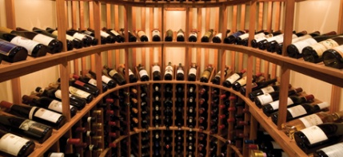
- Ensure all gas cylinders are correctly stored. This is importantly regardless if they are in use or empty. Use all retaining chains to limit movement of gas cylinders
- Remove empty kegs, casks and bottles on a regular basis
- Reseal casks when empty.

4.5 Monitor cellar temperature

Introduction
As can be seen through this manual, the importance of temperature in all aspects of beverage storing and dispensing is critical in ensuring the finished product is dispensed in its optimal condition.
Different temperatures have different reactions for different beverages.
Modern cellars are generally fitted with a cooling system, operating on the lines of an air-conditioning plant, ensuring the temperature remains relatively constant.
Optimal cellar temperature
Cellar cooling equipment should give a cellar temperature of 10°C to 12°C and run for a maximum of 16 hours out of every 24 hours.
It is essential that cellar operators check cellar temperature controls on a regular basis. This should be done daily. The temperatures should be recorded to identify any changes that need immediate attention.
It is always important to refer to manufacturer’s guidelines when maintaining optimal cellar conditions.
Maintaining cellar cooling equipment
Naturally one of the key elements of maintaining optimal cellar temperature is for any cellar cooling equipment to be working correctly.
In order for this to occur the following must be considered:
- There should be two quality thermometers in different parts of the cellar, located at different heights to ensure accurate measurements can be taken. It is important to note that they should not be placed in direct flow of cooler air or up against walls
- Equipment must be regularly serviced by specialised technicians
- Air vents on equipment must be kept clear. There should be no build up of fluff or dust.
Importance of cellar temperature for beer
Beer is a perishable product and, where possible, it is recommended that tap beer be stored and dispensed from a cool room set at between 2°C and 10°C.
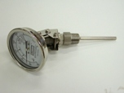
This will preserve quality of the beer over a longer period, retard bacterial infections and greatly enhance the dispensing of the product as lower temperatures;
- Lower operational gas pressures
- Reduce refrigeration load [remote systems]
- Reduce wastage

Where cool rooms are not available, the following points should be adhered to:
- Avoid temperatures above 20°C, as heat will accelerate the aging process
- Thorough cleaning of all equipment becomes extremely critical, as bacteria growth is accelerates at higher temperatures.
It is important to note that keg beer needs approximately 72 hours to adjust to cellar temperatures. This allows the taste, aroma and clarity to develop correctly.
Importance of cellar temperature for wine
The best temperature to store wine is between 12°C and16°C.
If your cellar conditions are not similar to the ‘standard cellar’, it is important to interpret the recommendations to your own conditions. However, a more active approach to evaluating your cellar is to note temperatures for the range of the days, between weeks and between seasons, by leaving a thermometer in your cellar.
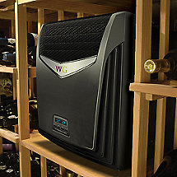
Significant fluctuations in daily or weekly temperatures tend to add to the speed of ageing commented on below, and may also increase the incidence of leakers and seepers. Vibration and direct light on the wine are damaging influences which should also be avoided.
If your storage has temperature maximums of no more than 10 to 15°C, then your storage conditions are good, and your wines will be at a similar stage of development to that indicated by your wine maker.
If your storage has temperature maximums of no more than 15 to 18°C, then your wine could he maturing 20 to 25% faster than above. Nevertheless, for quality the conditions are adequate, unless you would like to pamper your wines or your cellar is large and/or valuable. Your wine makers recommendations will be very useful, but bear in mind that your wines will develop faster.
If your storage has temperature maximums of no more than 18 to 24°C, then your storage conditions are not ideal; differences in speed of development will be evident even with storage over 2 to 3 years. Plan for holding less robust wines no more than 3 years.
If your storage has temperature maximums of more than 25°C, then your storage conditions are not very good, but do note that most good wines may still benefit for up to 2 or 3 years in this cellar.
Work Projects
It is a requirement of this Unit you complete Work Projects as advised by your Trainer. You must submit documentation, suitable evidence or other relevant proof of completion of the project to your Trainer by the agreed date.
4.1 To fulfil the requirements of this Work Project you are asked to research and identify common faults and possible reasons or remedies with the final product of:
- Beer
- Spirits
- Wine
- Post mix drinks.
4.2 To fulfil the requirements of this Work Project you are asked to research and identify who and how to report problems relating to bar equipment.
4.3 To fulfil the requirements of this Work Project you are asked to research and identify the benefits of using bin and keg key systems.
4.4 To fulfil the requirements of this Work Project you are asked to research and identify how to keep a cellar clean and tidy.
4.5 To fulfil the requirements of this Work Project you are asked to research and identify:
- The correct temperatures required for cellar operations
- How you can monitor temperatures.

Summary

Monitor quality of cellar products Use and maintain refrigeration systems
Test regularly quality of cellar products and identify faults
Beer – faults and remedies
Spirits – faults and remedies
Wine – faults and remedies
Post mix – faults and remedies
Importance of glassware.
Make adjustments within scope of individual responsibility or report faults to the appropriate person or people
Reporting cellar related faults
Options in reporting cellar related faults.
Use bin and keg card systems to assist in monitoring the quality of products and controlling stock
Aim of bin and keg key systems
Benefits of bin and keg key systems
Benefits of wine tagging systems.
Keep cellar tidy, clean and free from litter
Cleaning and maintaining cellar area.
Monitor cellar temperature
Optimal cellar temperature
Maintaining cellar cooling equipment
Importance of cellar temperature for beer
Importance of cellar temperature for wine.

Presentation of written work

1. Introduction
It is important for students to present carefully prepared written work. Written presentation in industry must be professional in appearance and accurate in content. If students develop good writing skills whilst studying, they are able to easily transfer those skills to the workplace.

2. Style

Students should write in a style that is simple and concise. Short sentences and paragraphs are easier to read and understand. It helps to write a plan and at least one draft of the written work so that the final product will be well organised. The points presented will then follow a logical sequence and be relevant. Students should frequently refer to the question asked, to keep ‘on track’. Teachers recognise and are critical of work that does not answer the question, or is ‘padded’ with irrelevant material. In summary, remember to:
- Plan ahead
- Be clear and concise
- Answer the question
- Proofread the final draft.

3. Presenting Written Work
Types of written work
Students may be asked to write:
- Short and long reports
- Essays
- Records of interviews
- Questionnaires
- Business letters
- Resumes.
Format
All written work should be presented on A4 paper, single-sided with a left-hand margin. If work is word-processed, one-and-a-half or double spacing should be used. Handwritten work must be legible and should also be well spaced to allow for ease of reading. New paragraphs should not be indented but should be separated by a space. Pages must be numbered. If headings are also to be numbered, students should use a logical and sequential system of numbering.
Cover Sheet
All written work should be submitted with a cover sheet stapled to the front that contains:
- The student’s name and student number
- The name of the class/unit
- The due date of the work
- The title of the work
- The teacher’s name
- A signed declaration that the work does not involve plagiarism.
Keeping a Copy
Students must keep a copy of the written work in case it is lost. This rarely happens but it can be disastrous if a copy has not been kept.
Inclusive language
This means language that includes every section of the population. For instance, if a student were to write ‘A nurse is responsible for the patients in her care at all times’ it would be implying that all nurses are female and would be excluding male nurses.
Examples of appropriate language are shown on the right:
Mankind | Humankind
Barman/maid | Bar attendant
Host/hostess | Host
Waiter/waitress | Waiter or waiting staff

Recommended reading
Cox, Jeff; 2003 (1st edition); Cellaring Wine: A Complete Guide to Selecting, Building, and Managing Your Wine Collection; Storey Publishing, LLC
Foley, Ray; 2010 (4th edition); Bartending for Dummies; For Dummies
Hellmicg, Mittie; The Ultimate Bar Book: 2006 (1st edition); Chronicle Books
Miron, Amanda & Brown, Douglas; 2005 (1st edition); The Professional Bar & Beverage Manager's Handbook: How to Open and Operate a Financially Successful Bar, Tavern, and Nightclub; Atlantic Publishing Company
Katsigris, Costas & Porter, Mary & Thomas, Chris; 2002 (3rd edition); The Bar and Beverage Book; Wiley
Plotkin, Robert; 2011 (1st edition); Successful Beverage Management; Barmedia
Shirke, Gajanan; 2010 (1st edition); Bar Management & Operations; Platinum Press
Smith, Jeff; 2006 (1st edition); The Best Cellar; Taylor Trade Publishing

Trainee evaluation sheet

Operate a cellar system
The following statements are about the competency you have just completed.
Please tick the appropriate box | Agree | Don’t Know | Do Not Agree | Does Not Apply
There was too much in this competency to cover without rushing.
Most of the competency seemed relevant to me.
The competency was at the right level for me.
I got enough help from my trainer.
The amount of activities was sufficient.
The competency allowed me to use my own initiative.
My training was well-organised.
My trainer had time to answer my questions.
I understood how I was going to be assessed.
I was given enough time to practice.
My trainer feedback was useful.
Enough equipment was available and it worked well.
The activities were too hard for me.

The best things about this unit were:

The worst things about this unit were:

The things you should change in this unit are:

Trainee self-assessment checklist
As an indicator to your Trainer/Assessor of your readiness for assessment in this unit please complete the following and hand to your Trainer/Assessor.

Operate a cellar system
 |  | Yes | No*
Element 1: Operate and maintain bulk dispensing systems
1.1 | Operate bulk dispensing systems in accordance with manufacturer's instructions and safety requirements
1.2 | Monitor temperature, carbonation and pump pressure
1.3 | Clean connectors, extractors and heads hygienically
1.4 | Set up nitrogen and integrated systems safely in accordance with manufacturer's specifications
1.5 | Identify faulty products and product delivery problems promptly and implement corrective action
Element 2: Operate and maintain beer reticulation systems
2.1 | Operate and clean beer reticulation systems in accordance with manufacturer’s instructions
2.2 | Follow safety procedures regarding handling, connecting and storing of gas
Element 3: Use and maintain refrigeration systems
3.1 | Measure refrigerator temperatures accurately and adjust correctly to comply with product requirements
3.2 | Clean and maintain refrigerator components
3.3 | Set or re-set walk-in alarms to manufacturer's specifications
3.4 | Recognise and repair/report basic mechanical faults in accordance with enterprise procedures
Element 4: Monitor quality of cellar products
4.1 | Test regularly quality of cellar products and identify faults
4.2 | Make adjustments within scope of individual responsibility or report faults to the appropriate person or people
4.3 | Use bin and keg card systems to assist in monitoring the quality of products and controlling stock
4.4 | Keep cellar tidy, clean and free from litter
4.5 | Monitor cellar temperature

Statement by Trainee:
I believe I am ready to be assessed on the following as indicated above:
Signed: _____________________________ | Date: ____________

Note:
For all boxes where a No* is ticked, please provide details of the extra steps or work you need to do to become ready for assessment.





